

**2 Minute Series**

**1st Week of June**

**(1st June to 6th June)**

Visit our website [www.sleepyclasses.com](http://www.sleepyclasses.com) or

Our [YouTube channel](https://www.youtube.com/user/SleepyClasses/videos) for entire GS Course **FREE** of cost

Also Available: Prelims Crash Course || Prelims Test Series

## GEOGRAPHY

<https://youtu.be/Wpm0uHmBhdM>

**Minor Forest Produce**

**Context**

Recently, **Centre revised the minimum support price (MSP) for minor forest produce.**

**Minor Forest Produce (MFP)?**

* MFP is defined under **The Scheduled Tribes and Other Traditional Forest Dwellers (Recognition of Forest Rights) Act, 2006,** popularly known as the Forests Rights Act (FRA).
* Minor Forest Produce (MFP) includes **all non-timber forest produce of plant origin and includes bamboo, canes, fodder, leaves, gums, waxes, dyes, resins and many forms of food including nuts, wild fruits, Honey, Lac, Tusser etc.**
* Panchayats (Extension to Scheduled Areas) Act, 1996 and Recognition of Forest Rights Act, 2006 conferred ownership of MFP to forest dwellers.
* Forest Rights Act also recognizes and vests individual forest-dwellers with forest rights to own and dispose minor forest products from forests where they had traditional access.

**Mechanism for Marketing of Minor Forest Produce (MFP) Through Minimum Support Price (MSP)**

* This is done under a **Centrally Sponsored scheme known as “Mechanism for marketing of Minor Forest Produce (MFP)through Minimum Support Price (MSP) and development of value chain for MFP**” as a measure of social safety for MFP gatherers.
* The MSP for MFP scheme was **started by the Centre in 2013 to ensure fair and remunerative prices to MFP gatherers.**
* The procurement of these MFPs will **commence in haat bazars, where tribals bring their produce with the facilitation provided by state government agencies and district collectors.**
* The **Scheme was been implemented in eight States having Schedule areas as listed in the Fifth Schedule of the constitution of India.**
* From **November 2016, the scheme is applicable in all States**.
* **Ministry of Tribal Affairs**, Government of India is the Nodal Ministry for implementation of the scheme which **will announce Minimum Support Price (MSP) for the selected MFPs with the technical support from TRIFED.**

**Note**

* **Ministry of Tribal Affairs has announced Inclusion of 23 additional Minor Forest Produce (MFP)** items and stipulation of their Minimum Support Price (MSP) under the Centrally Sponsored Scheme titled "Mechanism for Marketing of Minor Forest Produce (MFP) through Minimum Support Price (MSP) and development of value chain of MFP".
* **This decision enhancing the coverage from 50 to 73 items** comes in view of the exceptional and very difficult circumstances currently prevailing in the country on account of the **COVID-19** Pandemic, and the potential of the Ministry of Tribal Affairs scheme to offer the much needed support to the tribal MFP gatherers.

**Additional Info**

**Tribal Cooperative Marketing Development Federation of India (TRIFED)**

* It is a national-level apex organization **functioning under the administrative control of Ministry of Tribal Affairs.**
* It came into existence in **1987.**
* Its objective is **socio-economic development of tribal people by marketing of their products.**

## HISTORY

<https://youtu.be/AIcd3ag2gus>

**Peasant Movements**

**The Pagal Panthis**

* The Pagal Panthis Was **a Religious Movement** That Emerged In The Northern **Mymensingh** And **Sherpur** District Area Of The Province Of Bengal.
* This Region Was Inhabited Mainly By **Tribal Peoples** Such As The Garos, Hajangs, Dalus, Hudis And Rajvangshies, Who Were Mainly **Adherents Of Animism And Tribal Faiths.**
* The Region Served As A Base For A Religious Movement Called The Pagal Panthis, An Order Founded By Karim Shah.
* This Order Preached **Monotheism, Human Equality, Non-Violence** And Encouraged The People To Overcome Social And Religious Differences And **Avoid Conflicts And Dogma.**
* It Brought Together A Diverse Collection Of Tribes, Muslims, Hindus And Animists.
* The Movement Was **Shunned And Criticised By Bengali Muslim** Society And Its Leaders, Who Condemned Religious Syncretism And Referred To The Order As Pagal Panthis – Literally The Followers Of A "Mad Faith“.
* Under Tipu Shah, the son of Karim Shah, the order extended the philosophy to **demand equal socio-economic rights for the peasants** of the region.
* Tipu Shah proclaimed that **no unilateral ownership of land could be allowed**, as God had created humans as equals, thus granting every human an equal right to the lands.
* Those who forced peasants to pay taxes and oppressed them lost the moral right to rule over others.
* Ruling in the name of Allah, Tipu Shah enforced religious laws and encouraged tax resistance.
* The order had been famous for encouraging **revolts against the British East India Company**
* Under Tipu Shah, the order focused on **organising peasants in rebellions against oppressive taxes and laws imposed by the zamindars (landlords) and the British.**
* The region had been devastated by war between British forces and Burma.
* To meet the costs of war, severe taxation was imposed on the region's peasants by the Company and the landlords.
* Forcible collections and usurpation of property increased peasant discontent and disorder.
* The Pagal Panthis sought to protect and defend peasants from the militias of the landlords and the Company's armed forces.
* Basing his forces in a mud-fort near Sherpur, Tipu Shah proclaimed his rule in the name of Allah and assumed the religious and political leadership of the community.
* The people of the region stopped paying taxes to the British and followed Tipu Shah's rulings.
* Tipu Shah and his aides were arrested in 1833 and tried.
* The government subsequently met many of the peasant demands, including lowering the rent rate and other taxes. Compromises and agreements between the landlords, the Company and the peasants helped restore peace and order in the region.

## POLITY

<https://youtu.be/svAi_I4AXnM>

**Solar Charkha Cluster Mission**

**Solar Charkha Mission**

* The scheme **Mission Solar Charkha** by Ministry of Micro, Small and Medium Enterprises, is enterprise driven scheme and envisages setting up of ‘**Solar Charkha Clusters**’ which will have 200 to 2042 beneficiaries (Spinners, Weavers, Stitchers and other skilled artisans).  Each spinner will be given two charkhas of 10 spindles each.
* Based on the success of a **pilot project on Solar Charkha, set up at Khanwa village, Nawada District, Bihar** in 2016 which benefitted about 1180 artisans, Government of India accorded approval to set up 50 such clusters.



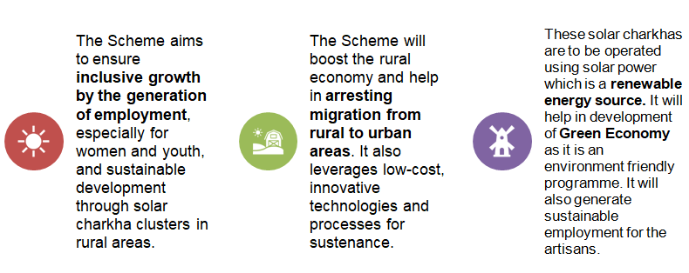

## ECONOMY

<https://youtu.be/VHlx5c7VNiY>

**USTR Section 301**

**News**

* The **US Trade Representative's** office has announced that it will start **Section 301** investigations against India and nine others for imposing or considering **digital services taxes** that may affect American companies.

**What’s the Tax**

* India levies **6%** tax in the form of **equalisation levy** on digital companies advertising revenue.
* Equalisation levy has been brought in **2016** on **cross border digital transactions** in to tax internet giants' digital advertising revenues from India.
* **Recently**, the government **expanded the scope of** the equalisation levy to include any purchase by an Indian or India-based entity through overseas ecommerce platform with effect from April 1.
* The government imposed **a new tax of 2%** in April, 2020 **on**:
  + Digital services rendered
  + In India
  + Against payments collected abroad.
* The levy is restricted to non-resident companies and is expected to chiefly affect American digital services giants Google, Face book, Apple and Amazon.

**Other countries that have already levied this tax or are considering them are**

* Austria, Brazil, the Czech Republic, the European Union, Indonesia, Italy, Spain, Turkey, and the United Kingdom.

**What’s the USTR ANNOUNCEMENT?**

* The **US Trade Representative's** office has announced that it will start **Section 301** investigations against India and nine others for imposing or considering digital services **taxes** that may affect American companies.

**What is USTR?**

* It is **a US government agency** responsible for developing and **recommending United States trade policy to the president** of the United States.
* It **also conducts trade negotiations** at bilateral and multilateral levels.

**What is this Section 301 of the Trade Act of 1974?**

* It **authorizes the President to take all appropriate action**, including tariff-based and non-tariff-based retaliation, to obtain the removal of any act, policy, or practice of a foreign government that violates an international trade agreement or is unjustified, unreasonable, or discriminatory, and that burdens or restricts U.S. commerce.
* Section 301 cases **can be self-initiated** by the United States Trade Representative (USTR) or as the result of a **petition filed** by a firm or industry group.

**What happens when a Section 301 investigation begins?**

* The Section 301 investigation will include, typically, **a public hearing** based on **written objections and comments**, which, according to a simultaneous announcement in the Federal Register, the US government’s gazette, can be submitted till July 15.

**India’s Response**

* **India’s commitments** under the **General Agreement on Trade in Services** allow **such taxes**.
* India’s taxes **do not specifically target American companies**.
* India has not taken any commitment under GATS, in services sector, and **India is not required to give national treatment in that sector.**
* This **gives us flexibility to impose discriminatory tax** on services imports in sectors where we have not taken a commitment.

**Meanwhile, do find out about**

* Special 301 Report

## ENVIRONMENT

<https://youtu.be/Ge8QETX9MrI>

**Namdapha flying squirrel**

**INTRODUCTION**

* The **Namdapha flying squirrel** (*Biswamoyopterus biswasi*) is an **arboreal, nocturnal flying** squirrel **endemic to Arunachal Pradesh in northeast India**, where it is known from a single specimen collected in Namdapha National Park in 1981.
* In 1981, a team of scientists led by zoologist **Shyamrup Biswas** discovered the Namdapha flying squirrel (*Biswamoyopterus biswasi*) in the ironwood jungles of Arunachal Pradesh state, India.
* The Namdapha Flying Squirrel is only **known with certainty from a single individual collected in Namdapha** National Park, the **largest protected area in the Eastern Himalaya biodiversity hotspot**, at altitudes of between 100 and 350 meters above sea level.

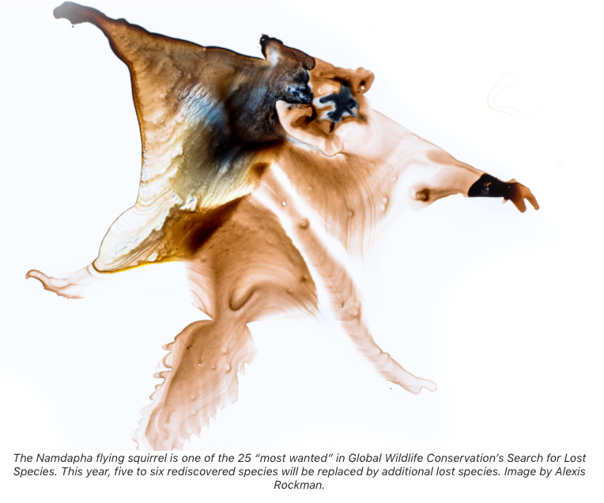

**Habitat**

* **No population estimate** is available for *B. biswasi*, but the **known habitat** is tall *Mesua ferrea* jungles, often on hill slopes in the catchment area of **Na Dihing River (particularly on the western slope of Patkai range) in northeastern India.**
* It is found in dry **deciduous montane forests** occupying **moist forest tracts** along streams.
* It may be **restricted to the area of a single valley** within the Namdapha National Park.
* This is an **arboreal species** that is likely **most active at dusk**.

**Status**

* The Namdapha flying squirrel is listed as **critically endangered** by the IUCN.
* Its range of the Namdapha flying squirrel may be restricted to a **single valley** and it is threatened by **poaching of animals** for food from within the park, and possibly by **habitat destruction**.
* It is **among the 25 “most wanted lost**” species that are the focus of **Global Wildlife Conservation’s “Search for Lost Species” initiative.**

**Important Points**

* Scientists have discovered a **new species of giant flying squirrel in China** belonging to one of the world’s rarest and most mysterious genera.
* The **first species in the genus, the Namdapha flying squirrel** (Biswamoyopterus biswasi), was described in 1981 and **hasn’t been seen since.**
* A second species, the **Laotian giant flying squirrel** (Biswamoyopterus laoensis), was described in 2013, but also from just a single specimen.
* Researchers believe the **conservation outlook** for the new species, the Mount Gaoligong flying squirrel (Biswamoyopterus gaoligongensis), **is better** than for its relatives, given its **greater abundance in the wild and prospects for community and government involvement to protect it.**

## INTERNATIONAL RELATIONS

<https://youtu.be/GDy4nKoVO5M>

# G7 *OR* G12

**G7**

* The heads of the six leading industrial countries met in the backdrop of the first oil shock and subsequent financial crisis in 1975 to discuss the global economy
* There were joined in 1976 by Canada and in 1998 by Russia
* Following the Russian annexation of Crimea, the G7 nations decided in March 2014 to meet without Russia
* India is officially invited by President Trump for the next G7 summit which will take place in September in America

**Expansion of G7**

* France first floated the idea of expanding G7 in 2003 and invited heads of government of several “emerging economies”. Later the host countries started organising meetings on sidelines of their summits.
  + India and China were invited to all those summits
* President Trump has suggested expanding G-7 to a G-10 or G-11
  + He has come up with a list of countries such as Australia, India, South Korea and Russia
* The group could become G-12 with the inclusion of Indonesia
* Trump is motivated by exclusion of China and inclusion of India and Russia at the same time
* For the expansion to take place, other members such as the UK, France, Germany, Italy, Japan and Canada have to be on-board